**Exercise 1: Logging Error Messages and Warning Levels (MANDATORY)**

Created a basic SLF4J logger and printed one error and one warning message.

**LoggingExample.java:**

package com.example.sl4j;

import org.slf4j.Logger;

import org.slf4j.LoggerFactory;

public class LoggingExample {

private static final Logger logger = LoggerFactory.getLogger(LoggingExample.class);

public static void main(String[] args) {

logger.error("This is an error message");

logger.warn("This is a warning message");

}

}

**Output:**

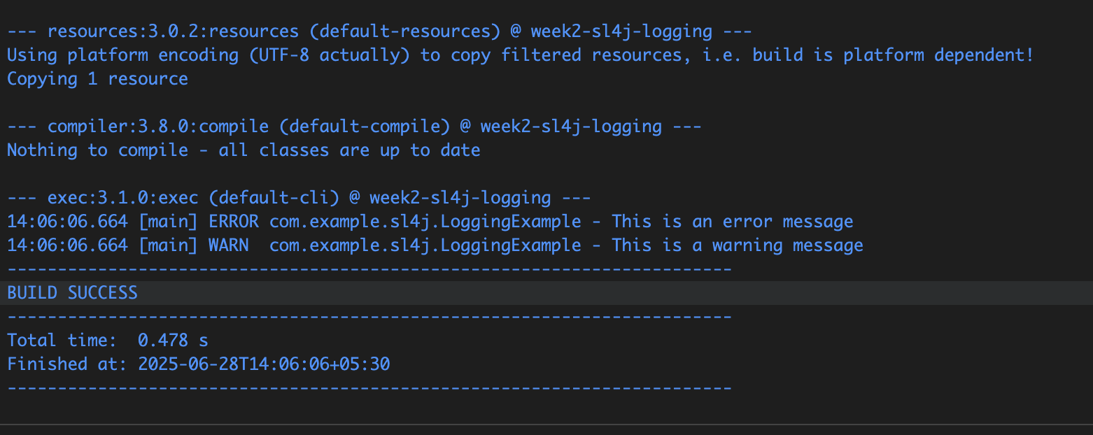

**Exercise 2: Parameterized Logging**

Used {} placeholders in logger messages to log user name, login attempts, and lock status.

**ParameterizedLoggingExample.java:**

package com.example.sl4j;

import org.slf4j.Logger;

import org.slf4j.LoggerFactory;

public class ParameterizedLoggingExample {

private static final Logger logger = LoggerFactory.getLogger(ParameterizedLoggingExample.class);

public static void main(String[] args) {

String user = "Shruti";

int loginAttempts = 3;

boolean isLocked = true;

logger.info("User {} has logged in", user);

logger.warn("User {} had {} failed login attempts", user, loginAttempts);

logger.error("User {} account locked: {}", user, isLocked);

}

}

**Output:**

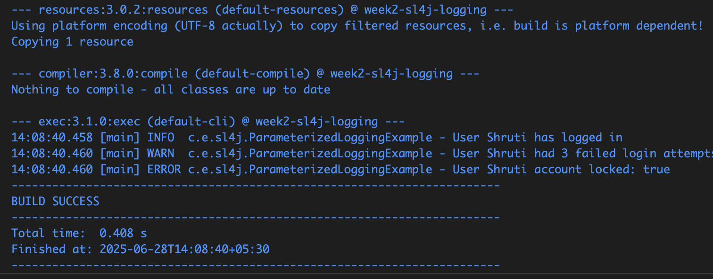

**Exercise 3: Using Different Appenders**

Logged info, warning, and error messages that appeared both in the console and in the generated **app.log** file.

**Logback.xml:**

<configuration>

<appender name="console" class="ch.qos.logback.core.ConsoleAppender">

<encoder>

<pattern>%d{HH:mm:ss.SSS} [%thread] %-5level %logger{36} - %msg%n</pattern>

</encoder>

</appender>

<appender name="file" class="ch.qos.logback.core.FileAppender">

<file>app.log</file>

<append>true</append>

<encoder>

<pattern>%d{HH:mm:ss.SSS} [%thread] %-5level %logger{36} - %msg%n</pattern>

</encoder>

</appender>

<root level="debug">

<appender-ref ref="console" />

<appender-ref ref="file" />

</root>

</configuration>

**MultiAppenderExample.java:**

package com.example.sl4j;

import org.slf4j.Logger;

import org.slf4j.LoggerFactory;

public class MultiAppenderExample {

private static final Logger logger = LoggerFactory.getLogger(MultiAppenderExample.class);

public static void main(String[] args) {

logger.info("This is an info message");

logger.warn("This is a warning message");

logger.error("This is an error message");

}

}

**Output:**

**Warning messages in app.log**

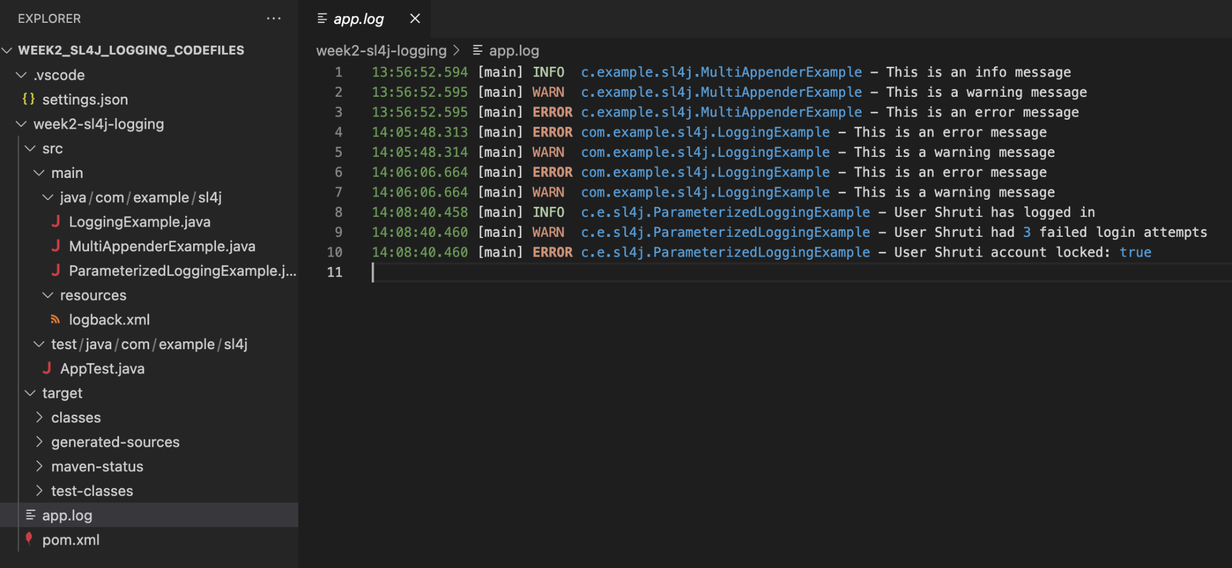

**On running MultiAppenderExample.java**

